Analysis, Design & Testing Document
State of New Hampshire
INT_FIN_093 CB Recon – Citizens Bank
Document Properties
Author | Ritchie Bachini / Melanie Rose Nunez
Creation Date | 06/30/2025
Last Updated | 2/19/2026
Document Reference
Version | 1.6

Document Control

Change Record
31
Date | Author | Version | Change Reference
06/30/2025 | Ritchie Bachini | 1.0 | Initial draft: Executive Summary, Functional Specification, Testing Process
07/09/2025 | Ritchie Bachini | 1.1 | Updated Functional Requirements, business process flow, testing process
07/11/2025 | Lawson Herman | 1.1 | Initial Functional Review Completed
7/11/25 | Lila Elizalde | 1.2 | review & updates
7/14/25 | Lila Elizalde | 1.2 | Final review/updates- ready for SONH
08/06/2025 | Benjamin Almazan Jr. | 1.3 | Updated Technical Specifications and Testing Process
2/12/2026 | Irie Mack Pable | 1.4 | Updated the navigation and URL links using the consolidated web app roles.
2/19/2026 | Melanie Rose Nunez | 1.5 | Updated the mapping to align with the bank format attached by Mark Larochelle incorporating the clarified cash code definitions
2/23/2026 | Melanie Rose Nunez | 1.6 | Updated the field mapping based on our call with Mark Larochelle

Contents
1 Document Control 2
1.1 Change Record 2
2 Executive Summary 4
2.1 Business Objectives 4
2.2 Assumptions 4
3 Functional Specifications 6
3.1 Overview 6
3.2 Functional Requirements 6
3.3 Business Process Flow 13
3.4 Field Mapping 13
Technical Specifications 16
3.5 Solution Overview 16
3.6 Technical Configurations 16
4 Testing Process 21
5 Signature 30
5.1 Functional Specification 30
5.2 Technical Specification 30
5.3 Design Sign-off 30
5.4 Testing Sign-off 30
6 Appendix 31

Executive Summary
The State of New Hampshire requires an interface that will automate the process of the file from the Citizens Bank to Infor FSM for payment reconciliation, when a payment is cleared by the bank (paid) the file will contain the change of the payment status from “open” to reconciled. The inbound file will be used primarily to reconcile the cash ledger transactions in the Cash Management module.

Business Objectives
This inbound interface will allow SoNH to automatically reconcile the cash ledger transactions in the “Manage Cash Ledger Transactions” under Cash Ledger Processing. Once the bank reconciliation file is sent to SoNH’s sftp directory, the file will be scanned, and records will be loaded into Cash Ledger Bank Updates Maintenance. Once the records are loaded, IPA will trigger the “Update Ledger Transactions” action to update the status of the cash ledger transactions.

Assumptions
This specification assumes that the following statements are true. Any changes can result in a change order and will be managed using the change order process as defined in the Service Workorder.

- This functional specification defines the complete scope for interface development. Functions not described here are excluded from the deliverables.
- This Citizens Bank reconciliation inbound interface is applicable only to transactions processed in FSM, and for the bank accounts for which the mapping definitions on this document apply.

- The extract of recon file from Citizens Bank will be automated and will be placed in the bank’s sftp directory. SoNH to ask the bank’s sftp directory.

- A job will be set to schedule this daily. However, the bank will have capability to manually place the file to the sftp directory on demand.

- Infor FSM will have access to the target directory. SoNH to ensure Bank engagement and involvement for testing.
- Infor FSM and Citizens Bank test systems are available for testing and development of the interface.
- All setup/configurations applicable to this interface within FSM have been completed.
- Cash code 0042 will be used for testing only the Citizens Bank reconciliation and cash update. Other cash codes below highlighted in yellow are disbursing accounts and are potential to use check reconciliation and cash update.

CashCode | Description | Currency | Financial Institution | Active
0011 | CB1 Receiving | USD | CITIZENS BANK | Yes
0013 | CB2 Federal Concentration | USD | CITIZENS BANK | Yes
0020 | CB2 TANF Payments | USD | CITIZENS BANK | Yes
0021 | CB2 Non-Federal Electronic | USD | CITIZENS BANK | Yes
0024 | CB Turnpike Tolls | USD | CITIZENS BANK | Yes
0025 | CB1 SRF Custody Trust | USD | CITIZENS BANK | Yes
0037 | CB1 Payroll | USD | CITIZENS BANK | Yes
0038 | CB2 Manual Checks | USD | CITIZENS BANK | Yes
0039 | CB2 Bridges | USD | CITIZENS BANK | Yes
0042 | CB2 MMIS 0042 | USD | CITIZENS BANK | Yes
0043 | CB1 DOC | USD | CITIZENS BANK | Yes
0045 | CB1 Dept. of Safety | USD | CITIZENS BANK | Yes
0048 | CB1 Dept. of Revenue | USD | CITIZENS BANK | Yes
0049 | CB1 Drinking Water SRF | USD | CITIZENS BANK | Yes
0051 | CB SRF Repayment | USD | CITIZENS BANK | Yes
0052 | CB2 Insurance Dept. EFT | USD | CITIZENS BANK | Yes
0055 | CB DWSRF Repayment | USD | CITIZENS BANK | Yes
0056 | CB1 Brownfields Cleanup Revolv | USD | CITIZENS BANK | Yes
0057 | CB Brownfields SRF Repayment | USD | CITIZENS BANK | Yes
0059 | CB1 Liquor Merchant | USD | CITIZENS BANK | Yes
0060 | CB1 Liquor Receiving | USD | CITIZENS BANK | Yes
0068 | CB Turnpike EZ Pass Merchant | USD | CITIZENS BANK | Yes
0079 | Turnpike EZPass Deposit Acct | USD | CITIZENS BANK | Yes
FE51 | Citizens CWSRF Fee Acct | USD | CITIZENS BANK | Yes
FE55 | Citizens DWSRF Fee Acct | USD | CITIZENS BANK | Yes
I045 | Citizens Gen FD Investment Acc | USD | CITIZENS BANK | Yes
I054 | Turnpike: Facility Sustainment | USD | CITIZENS BANK | Yes
I145 | Citizens - CD - General Fund | USD | CITIZENS BANK | Yes

- Notifications of import failures to be sent to DEAM, BOA and Treasury.
- Notifications on bank update process to be sent to DEAM, BOA and Treasury.
- Infor will provide the file layout for the Bank to provide the upload file.
- Bank recon inbound file will need to be decrypted.

Functional Specifications

Overview
The document can also be thought of as a “Functional Design Document” which describes the detailed design for Citizens Bank Cash Ledger Reconciliation interface automation.

Functional Requirements
Functional Requirement ID | Requirement Definition
3.2.1 | Transfer of Bank Recon Input File to SFTP
3.2.2 | IPA Picks up the File in SFTP
3.2.3 | IPA Import to CashLedgerBankUpdate Business Class
3.2.4 | Import Notification – Successful
3.2.5 | Import Notification – Failed and Error Handling
3.2.6 | Update Ledger Transactions
3.2.7 | Notification for Successful Update of Ledger Transactions
3.2.8 | Notification for Update of Ledger Transactions with Error
3.2.9 | Review of Cash Ledger Transactions Status

TRANSFER OF BANK RECON INPUT FILE TO SFTP
The extraction of the reconciliation file from Citizens Bank and placement on the sftp directory will be automated. However, the bank will be allowed to access and manually place the reconciliation file to the bank’s sftp directory on demand. Infor FSM will be able to retrieve files from the bank’s sftp site. <SoNH to coordinate with the bank >

The recon file will be extracted and placed to sftp directory per bank account or cash management account.

Functional Requirement ID | Requirement Definition
3.2.1.1 | The bank must establish a secure SFTP connection for file transfer.  SFTP Directory: /Inbox
3.2.1.2 | Filename format O1601.RCN.csv
3.2.1.3 | Input files must adhere to FSM CashLedgerBankUpdate format.

IPA PICKS UP THE FILE IN SFTP
IPA automatically picks up files from the SFTP folder location for further processing.
Functional Requirement ID | Requirement Definition
3.2.2.1 | Once input files are detected in the SFTP Input Folder, the import process should be initiated immediately.

IPA IMPORT TO CASHLEDGERBANKUPDATE BUSINESS CLASS
IPA will automatically import FSM formatted files into FSM's Cash Ledger Bank Update business class for further processing.
Functional Requirement ID | Requirement Definition
3.2.3.1 | Interface Type Inbound  Source System Citizens Bank (CB)  Target System Infor Financials and Supply Management (FSM)  Frequency Once input files are detected  Trigger File existing in designated bank SFTP directory  File Location /Inbox  File Name O1601.RCN  File Format .csv

IMPORT NOTIFICATION – SUCCESSFUL
IPA will notify the DEAM, BOA and Treasury for the successful import.
To | <!ToRecipientList>
Cc | <!CCRecipientList>
Bcc | <!BCCRecipientList>
From | <!FromEmailAddress>
Subject | [<appProdline>]-WU#<WorkUnit>:NHFIRST - Cash Ledger Bank Update imported successfully.
Body Header | The Cash Ledger Bank Update has been imported successfully.
Body | File Name: <File Name>
Body Footer | This is a system-generated email by Infor Process Flow. Do not reply.    Statement of Confidentiality: The contents of this message and any attachments, if any, may contain confidential or privileged information and are intended for the exclusive use of the addressee(s). Any unauthorized disclosure, reproduction, use or dissemination (either whole or in part) is prohibited. If you are not the intended recipient of this message, please notify the sender immediately and destroy all copies of this message, along with attachments, if any, from your system.

IMPORT NOTIFICATION – FAILED AND ERROR HANDLING
IPA detects import errors and notifies the DEAM, BOA and Treasury.
Functional Requirement ID | Requirement Definition
3.2.5.1 | Automated error detection mechanism for the following:  A. File-Level Errors:  1. Corrupt File – file in sftp is unreadable  2. Unsupported File Format - file in sftp is not in a required format in this document  3. File Name Mismatch – file in sftp is not in a required file naming format in this document  4. Duplicate File – file is imported multiple times, causing redundant data (duplicate can be identified via file name or run group)  B. Data Validation Errors:  1. Missing Required Fields - A required field is blank.  2. Invalid Data Format - data does not follow the expected format.  3. Truncated Data – Data is cut off due to column size limitations.  4. Reference Data Mismatch – Referenced IDs (e.g., Vendor ID) do not exist in FSM.  5. File Header Missing - The system expects headers, but they are not present, causing a format mismatch.  6. Mismatched Data Types - data provided does not match data types
3.2.5.2 | A notification configured to alert DEAM and Treasury distribution group promptly upon error detection. <SONH to confirm>
3.2.5.3 | DEAM or Treasury to coordinate with the bank to resolve the errors and re-upload fixed files to the bank’s SFTP location for re-processing by IPA. <SONH to confirm>
3.2.5.4 | IPA picks up and reprocess fixed error files seamlessly upon re-upload.

To | <!ToRecipientList>
Cc | <!CCRecipientList>
Bcc | <!BCCRecipientList>
From | <!FromEmailAddress>
Subject | [<appProdline>]-WU#<WorkUnit>:NHFIRST - Cash Ledger Bank Update file has import errors.
Body Header | A Cash Ledger Bank Update file for Account <Account Number> has import errors.  Pls check and resubmit files.
Body | File Name: <File Name>  Error File: <Error File Attachment>  Please submit a help desk ticket.
Body Footer | This is a system-generated email by Infor Process Flow. Do not reply.    Statement of Confidentiality: The contents of this message and any attachments, if any, may contain confidential or privileged information and are intended for the exclusive use of the addressee(s). Any unauthorized disclosure, reproduction, use or dissemination (either whole or in part) is prohibited. If you are not the intended recipient of this message, please notify the sender immediately and destroy all copies of this message, along with attachments, if any, from your system.

UPDATE LEDGER TRANSACTIONS
Upon successful import of Cash Ledger Bank Update records, they will be accessible in the Cash Ledger Bank Update Maintenance table under the CashLedgerBankUpdate business class. IPA will then initiate an interface action and run the Update Ledger Transactions for a run group in the input file and check the results.
Navigation: Cash > Cash Ledger > Processing tab > Process section > Bank Update Maintenance

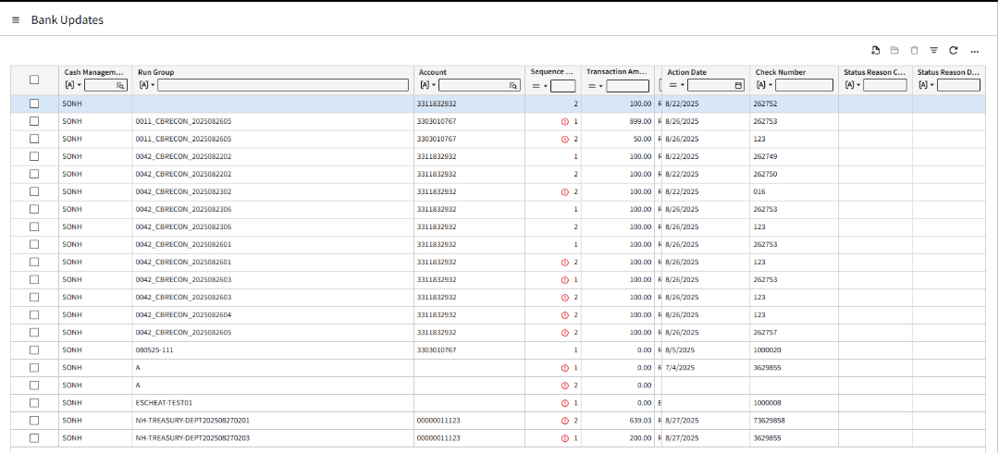

Functional Requirement ID | Requirement Definition
3.2.6.1 | Please take note of the following parameters:  Field Value Required  Cash Management Group “SONH” Yes  Run Group <CashCode>_<*Bank Abbreviation>recon_YYYYMMDD *Citizens Bank = CB (e.g. 0042 _CBrecon_20250730) Yes  Ignore Duplicate Check Numbers Uncheck No  Bank Account Number Leave <blank> No  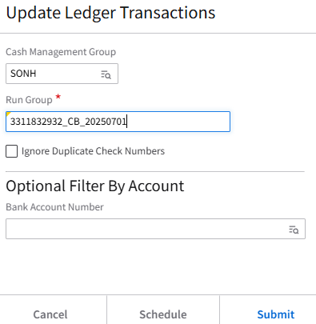
3.2.6.2 | Successful update will result in Cash Ledger Transactions with status “Reconciled” or the status name as indicated in reconciliation file.
3.2.6.3 | Error Handling:  At the end of the process, IPA will send an email to the end user telling them the file/run group name, number of records, and whether errors were encountered.  In cases where errors are encountered during the bank update process, Treasury needs to check the errors via Cash > Cash Ledger > Processing tab > Process section > Bank Update Maintenance and resolve the error.  After correcting the error, Treasury must manually run the Update Ledger Transactions to update the Cash Ledger transactions that went into error.  

NOTIFICATION FOR SUCCESSFUL UPDATE OF LEDGER TRANSACTIONS
IPA will notify the DEAM, BOA and Treasury for the successful update.
To | <!ToRecipientList>
Cc | <!CCRecipientList>
Bcc | <!BCCRecipientList>
From | <!FromEmailAddress>
Subject | [<appProdline>]-WU#<WorkUnit>:NHFIRST – Successful Update of Cash Ledger Transactions
Body Header | The Update of Cash Ledger Transactions for Run Group <Run Group> was successful.
Body | File Name: <File Name>  Run Group: <Run Group>  No. of Records: <No.of Records>  Work Unit: <WorkUnit>
Body Footer | This is a system-generated email by Infor Process Flow. Do not reply.    Statement of Confidentiality:The contents of this message and any attachments, if any, may contain confidential or privileged information and are intended for the exclusive use of the addressee(s). Any unauthorized disclosure, reproduction, use or dissemination (either whole or in part) is prohibited. If you are not the intended recipient of this message, please notify the sender immediately and destroy all copies of this message, along with attachments, if any, from your system.

NOTIFICATION FOR UPDATE OF LEDGER TRANSACTIONS WITH ERROR
IPA detects the errors and notifies DEAM, BOA and Treasury.
Functional Requirement ID | Requirement Definition
3.2.7.1 | A notification configured to alert agency distribution group promptly upon error detection.
3.2.7.2 | Real-time detection of update errors within FSM. Upon update of the ledger transactions per run group, the remaining records in the CashLedgerBankUpdate business class contain error messages.
3.2.7.3 | Treasury resolves the error/s manually and re-runs the Update Ledger Transactions until the records are completely updated.

To | <!ToRecipientList>
Cc | <!CCRecipientList>
Bcc | <!BCCRecipientList>
From | <!FromEmailAddress>
Subject | [<appProdline>]-WU#<WorkUnit>:NHFIRST - Update of Cash Ledger Transactions With Error
Body Header | The Update of Cash Ledger Transactions for Run Group <Run Group> encountered an error. Please correct the error manually and re-run the Update Ledger Transactions.
Body | File Name: <File Name>  Run Group: <Run Group>  No. of Records: <No.of Records>  No. of Successful Records: <Total No.of Records less No.of Records with Error>  No. of Failed Records: <No.of Records with Error>  Work Unit: <WorkUnit>  <Link to Cash Ledger Bank Update Maintenance>  Please submit a help desk ticket.
Body Footer | This is a system-generated email by Infor Process Flow. Do not reply.    Statement of Confidentiality:The contents of this message and any attachments, if any, may contain confidential or privileged information and are intended for the exclusive use of the addressee(s). Any unauthorized disclosure, reproduction, use or dissemination (either whole or in part) is prohibited. If you are not the intended recipient of this message, please notify the sender immediately and destroy all copies of this message, along with attachments, if any, from your system.

Navigation: Cash > Cash Ledger > Processing tab > Process section > Bank Update Maintenance



REVIEW OF CASH LEDGER TRANSACTIONS STATUS
Successful update of cash ledger transactions in FSM marks the completion of the process and checks the status of the Cash Ledger transactions as indicated in the bank reconciliation file.
Cash > Cash Ledger > Processing tab > Process section > Transactions > All Transactions tab > Filter Bank Transaction Code or Status
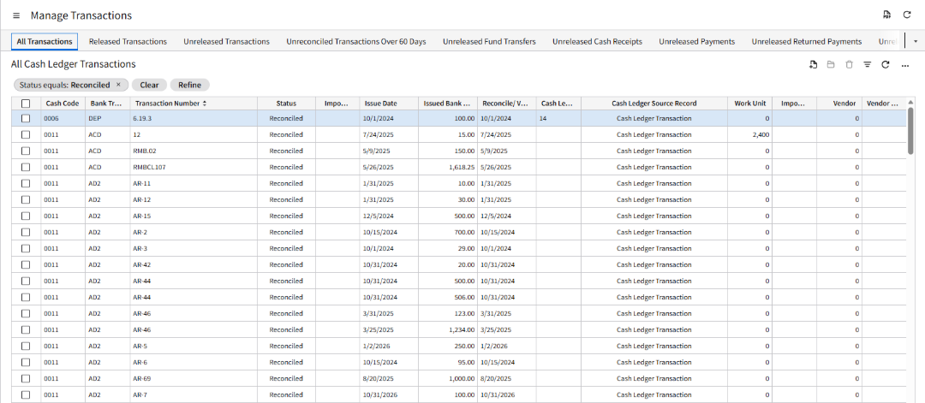

Business Process Flow

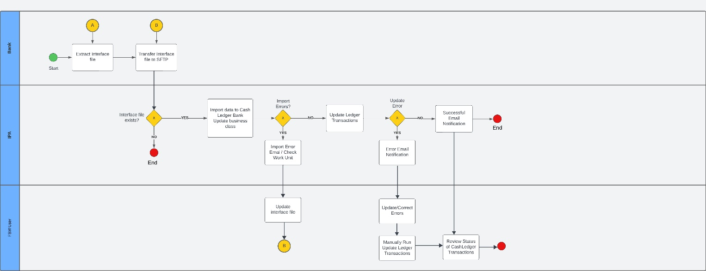

Field Mapping
FSM Field | Type | Field Size | Required Field? | Remarks | Sample Value | Bank Values /Fields
CashLedgerBankUpdate Business Class |  |  |  |  |  | Note: Use the Description column in the bank format below for the mapping:
CashManagementGroup | AlphaUpper | 4 | Yes | Default value of "SONH"
RunGroup | AlphaUpper | 30 | Yes |  | 0042_CBrecon_20250701 | <Cash Code>_<*Bank Abbreviation>recon_YYYYMMDD  *Citizens Bank = CB
CashManagementAccount | AlphaUpper | 35 | Yes |  | 3311832932 | Account Number
Sequence Number | Numeric | 10 | Yes | IPA to assign sequence number based on the detail record sequence | 1
TransactionAmount | Decimal | 16.2 | No | With 2 decimals | 000000028735  (read as 287.35) | Dollar Amount
CashLedgerUpdateAction | Numeric | 2 | Yes | If status of bank =”P”, mark update action as  4 = “Paid”.  If “R”, mark update action as 6 = “Reconcile” | R | Status Code
ActionDate | YYYYMMDD | 8 | Yes | Need to transform the date format from the bank field from MMDDYY to YYYYMMDD | 010926 | Paid Date
CheckNumber | AlphaUpper | 22 | Yes |  | 0000262751  (read as 262751) | Check Serial Number
CashCode | AlphaUpper | 20 | No | FSM Cash Code Associated with the Account Record  CashCode.CashCode where CashCode. BankAccountNumber = CashLedgerBankUpdate.CashManagementAccount | 0042
BankTransactionCode | AlphaUpper | 10 | No | Default value of “CHK” | CHK

The file being received from Citizens is fixed length with the following format and will be mapped to the FSM’s format above:
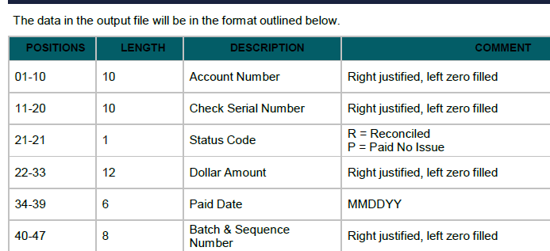
Position 40-47 Batch and Sequence Number will not be mapped to FSM.
Sample:
33118329320000262751R00000002873501092645236521

Extract Sample | 
3311832932
0000262751
R
000000028735
010926
45236521

Technical Specifications

Solution Overview
A custom IPA will be crated to perform the automated interface and Cash Ledger Bank Update action for files coming from Citizen’s Bank. As the files will be following an FSM standard format, the IPA will upload the transactions via the DB Import tool. Data validation will be handled by FSM and any errors will be collected by the IPA to be sent as an attachment in an email notification. Once the interface has completed, the input file will be archived in a designated directory within the provisioned SFTP server.

Technical Configurations

File Channel
Configure a file channel to monitor for any incoming source files for processing. The process and error directory contents will be stored in the file storage. A single work unit will be created for each source file.
See Infor Landmark Technology Administration Guide and Infor Process Automation Administration Guide for CloudSuite for more detailed information on administration of file channels and receivers.

File Channel Setup
Channel Name | SoNH_CashLedgerBankUpdate-Citizens
Description | Cash Ledger Bank Update inbound interface from Citizen's Bank
Enabled | True
File Channel Type | Remote
Source File Directory | /Infor_FSM/CashLedgerBankUpdate/INT-093/Input
File Match Case Sensitivity | Ignore Case
Error File Directory | /Infor_FSM/CashLedgerBankUpdate/INT-093/Error
In-progress File Directory | /Infor_FSM/CashLedgerBankUpdate/INT-093/In-Progress
File Scan Interval in Minutes | 5

File Transfer Connection
Host | sftp.inforcloudsuite.com
Protocol | SFTP
User
Password
* For security purposes, request for the UserName & Password from your System Administrator.

File Receiver Setup
Channel Name | SoNH_CashLedgerBankUpdate-Citizens
Receiver | CashLedgerBankUpdate
Description | CashLedgerBankUpdate IPA interface for Citizen's Bank
File Name | *.csv
Ignore Delete Errors | false
ProcessFlow | SoNH-INT-FIN-093-CitizensBankCBRecon
Data | File Name
Startup Type | Automatic

Process Flow Design

System Configuration Setting

Configuration: fsm

Properties
Property Name | Description | Value
FSM_FIN_CitizensBankCBReconInbound_INT_093_ArchiveDirectory | Archive Directory | /Infor_FSM/CashLedgerBankUpdate/INT-093/Archive
FSM_FIN_CitizensBankCBReconInbound_INT_093_BCCList | BCC recipients
FSM_FIN_CitizensBankCBReconInbound_INT_093_CCList | CC recipients
FSM_FIN_CitizensBankCBReconInbound_INT_093_CashManagementGroup | Default Cash Management Group | SONH
FSM_FIN_CitizensBankCBReconInbound_INT_093_EmailTo | Default email recipient
FSM_FIN_CitizensBankCBReconInbound_INT_093_ErrorFileHeader | CashLedgerBankUpdate error list file header | CashManagementGroup,RunGroup,Account,TransactionAmount,TransactionDate,ErrorMessage
SoNH_CitizensDecryption_Inbound | Decryption Flag | false
FSM_FIN_CitizensBankCBReconInbound_INT_093_DecryptionServiceName | Decryption service name | <TBD>

File Transfer Connection
Host
Protocol
User
Password
File System
* For security purposes, request for the UserName & Password from your System Administrator.

Async Queue Setup
Additional setup to set VendorImport queue history for IPA to retrieve status. To set up, go to Async Administrator à Setup à Search for CashLedgerProcessing queue à Under queue Mappinings, search for CashLedgerBankUpdate action à Set “Save History” to true:
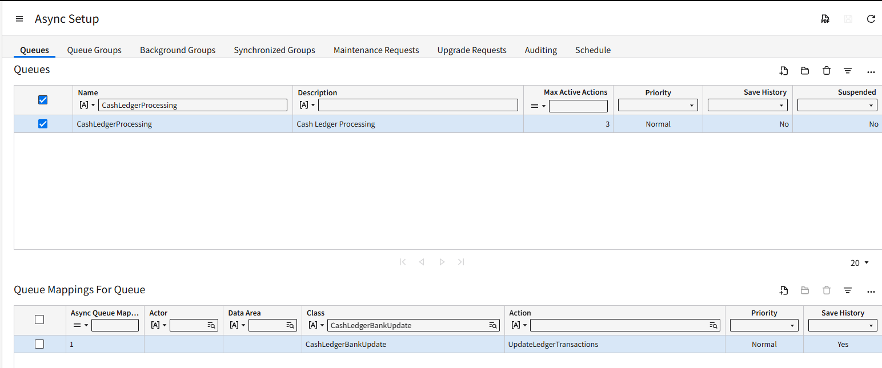

Process Flow: SoNH-INT-FIN-093-CitizensBankCBRecon
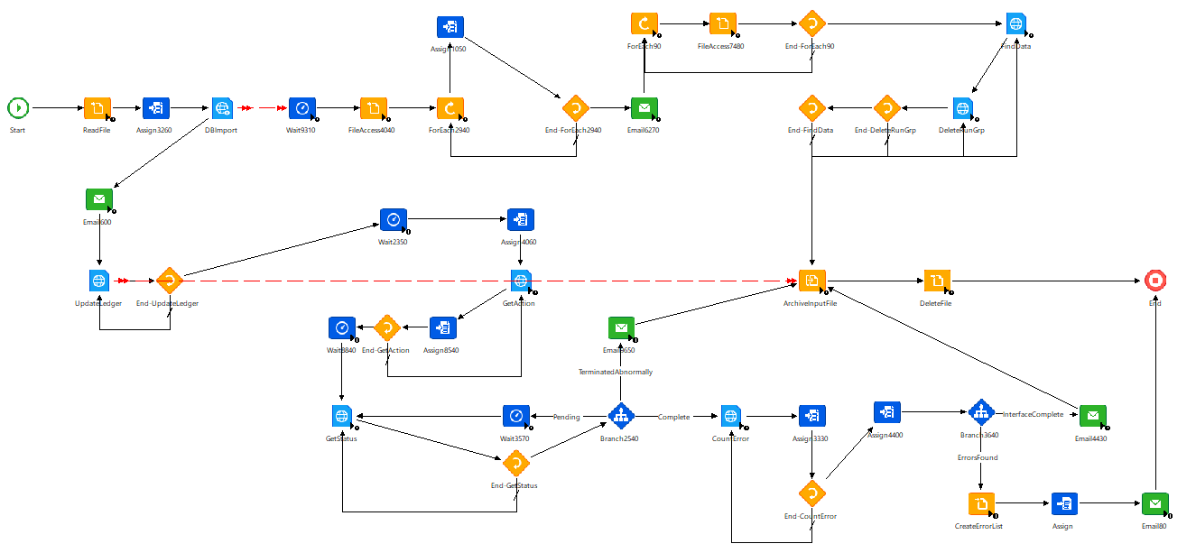

Trigger
This process flow is triggered via File Channel.

Variables
Variable Name | Type | Description | Value
vFileName | String |  | vFileName
vFile | String |  | ProcessedFileDirectory + "/" + FileName
vBusinessClass | String |  | "CashLedgerBankUpdate"
vErrorFileDirectory | String |  | ErrorFileDirectory
vErrorFile | String | DBImport Error File Directory and Name | ErrorFileDirectory + "/" + FileName
vRunGroup | String | RunGroup based on file name | FileName.split(".")[0]
vArchiveDirectory | String | Input file archive directory | _configuration.FSM.FSM_FIN_CitizensBankCBReconInbound_  INT_093_ArchiveDirectory
vAccountNumber | String | Account Number based on file name | FileName.split("_")[0]
vToRecipientList | String | Primary email recipient list | _configuration.FSM.FSM_FIN_CitizensBankCBReconInbound_  INT_093_EmailTo
vCCRecipientList | String | CC email recipient list | _configuration.FSM.FSM_FIN_CitizensBankCBReconInbound_  INT_093_CCList
vBCCRecipientList | String | BCC email recipient list | _configuration.FSM.FSM_FIN_CitizensBankCBReconInbound_  INT_093_BCCList
vEmailFrom | String | From Email address | _configuration.system.mailFrom != "" ? _configuration.system.mailFrom : "noreply-cloudnotification@infor.com"
vEmailLogoUrl | String | Email logo URL for standard footer | _configuration.FSM.SoNH_EmailLogo
vErrorFileOne | String | DBImport Error file name place holder
vActionName | String | Async Action name place holder
vDateAndTimeNow | String | Async Queue date time filter place holder
vActionReq | String | Async Action Request ID place holder
vCashManagementGroup | String | Default Cash Management Group | _configuration.FSM.FSM_FIN_CitizensBankCBReconInbound_INT_  093_CashManagementGroup
iRecsProcessed | Integer | Records process count place holder | 0
iErrorRecCount | Integer | Error records count place holder | 0
iTotalRecCount | Integer | Total records processed place holder | 0
vErrorHeader | String | CashLedgerBankUpdate  Error file header (post-DBImport) | _configuration.FSM.FSM_FIN_CitizensBankCBReconInbound_INT_  093_ErrorFileHeader
vNL | String | New Line variable | "\r\n"
vErrorList | String | CashLedgerBankUpdate  Error file contents (post-DBImport) place holder
vMaintenanceScreenLink | String | CashLedgerBankUpdate  Maintenance screen link  placeholder

Testing Process
Initial testing will be conducted without actual transmission of files from Citizens Bank.
Once validation of the file format is completed, actual testing with the Citizens Bank will follow.

TRANSFER OF RECONCILIATION File to SFTP

Scenario | Expected Result
Verify SFTP file transfer | File successfully transferred to SFTP
Verify that the file appears in the correct directory of the SFTP server. | The file should be visible and accessible in the designated directory.
- File is dropped in input directory
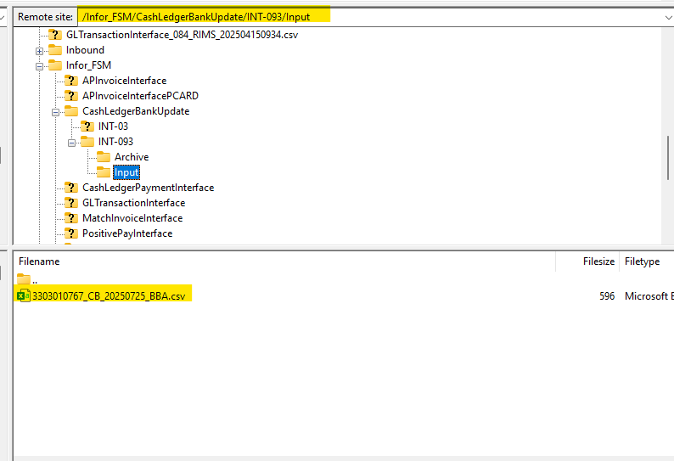
- File is archived after processing
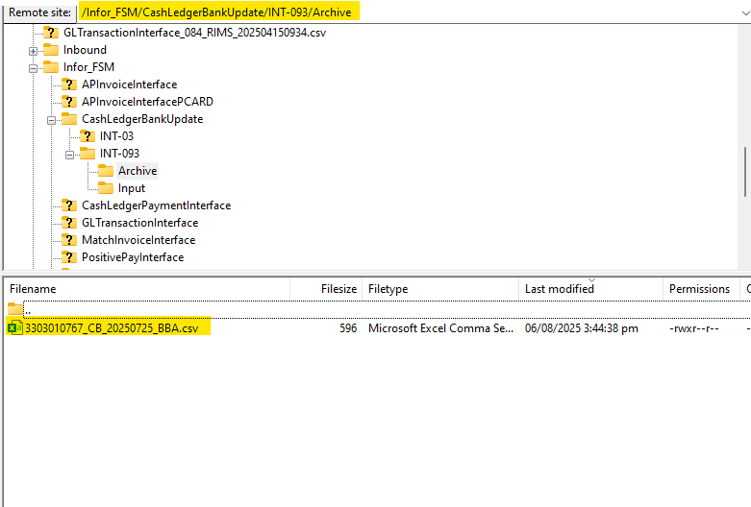

IPA PICKS UP THE FILE IN SFTP
Scenario | Expected Result
The transferred CashLedgerBankUpdate layout file from the bank in the SFTP location monitored by IPA. | IPA should detect and pick up the file from the SFTP location.
Trigger IPA’s automated process to pick up the file. | The automated process should be executed within the defined timeframe.
Verify that IPA detects and retrieves the file within the expected timeframe. | Confirmation in SFTP directory that the file retrieval event is recorded and archived.
- File Channel picks up file and triggers IPA Workunit:
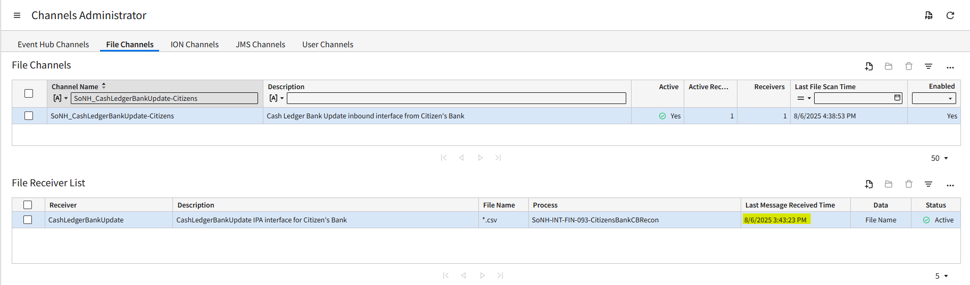
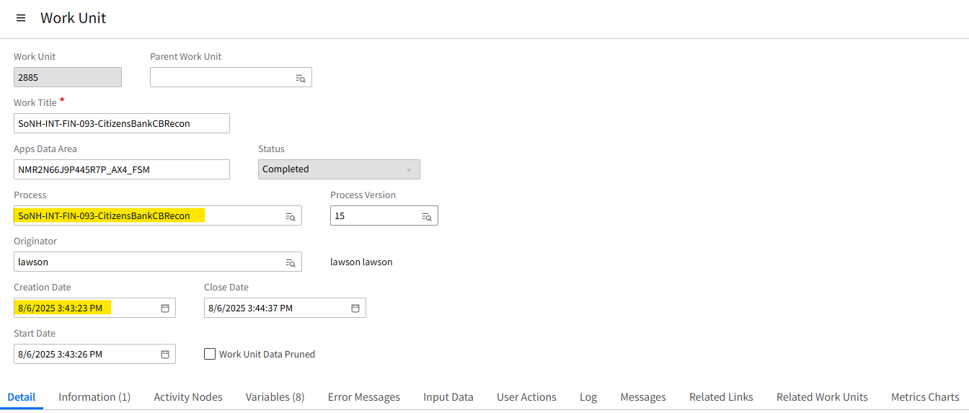

IPA IMPORT INTO CASHLEDGERBANKUPDATE BUSINESS CLASS
Scenario | Expected Result
Trigger the automated loading process for a transformed file into FSM. | IPA should successfully load the transformed data into the CashLedgerBankUpdate business class.
Verify that FSM validates and loads the data into the CashLedgerBankUpdate business class. | Validation checks should ensure data accuracy and completeness.
Check data integrity by reviewing loaded records against expected content and format. | Review of loaded records should match the expected content and format in FSM.

- Workunit logs showing that all four records contained in the file have been uploaded to CashLedgerBankUpdate business class:
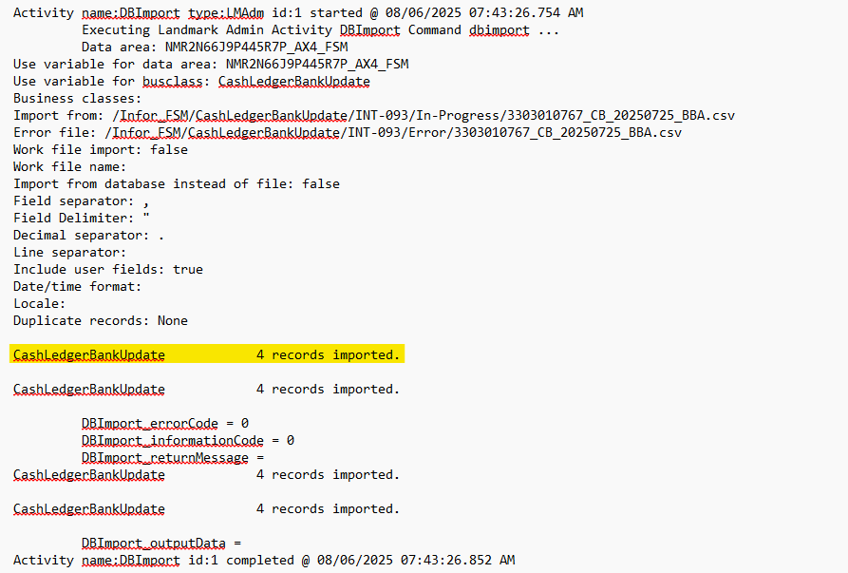

IMPORT ERROR DETECTION AND NOTIFICATION
Scenario | Expected Result
Introduce a deliberate error into an FSM layout file processed by IPA. | IPA should detect deliberate errors during processing.
Trigger the processing and verify that IPA detects the error. | Processing should stop upon error detection to prevent incorrect data integration.
Confirm that IPA halts processing and notifies the distribution group. | A timely notification should be sent to the designated distribution group with details of the error.
- Import error notification:
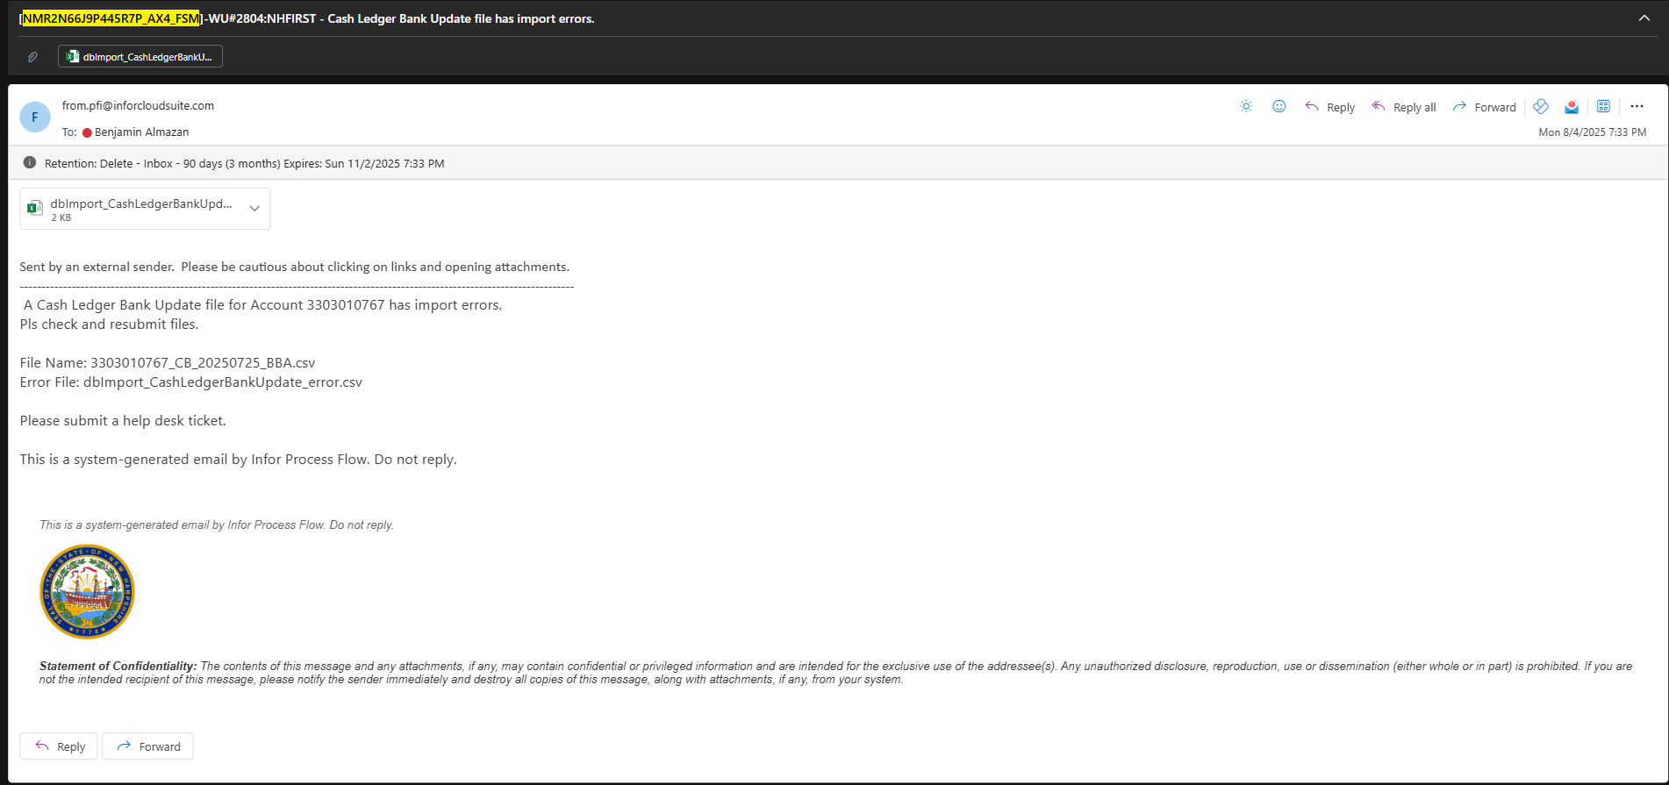
- Import error notification file attachment:
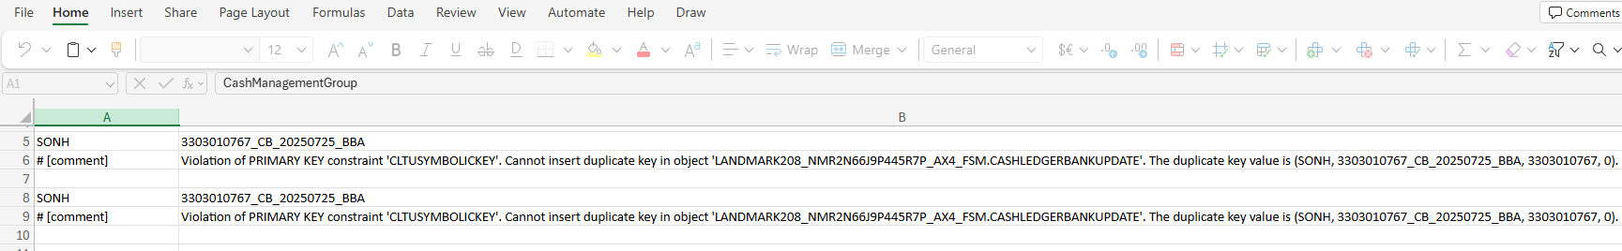

IMPORT ERROR RESOLUTION AND RE-PROCESSING
Scenario | Expected Result
Identify an error in an FSM layout file and resolve it offline. | The identified error should be resolved correctly in the FSM layout file offline.
Re-upload the fixed file to the SFTP location monitored by IPA. | IPA should detect the re-uploaded fixed file and initiate re-processing automatically.
Verify that IPA picks up the fixed file and successfully re-processes it. | Confirmation that the re-processed file integrates successfully without errors.

IPA UPDATE OF CASH LEDGER TRANSACTIONS
Scenario | Expected Result
IPA automatically run Update Ledger Transactions using the Run Group within CashLedgerBankUpdate business class. | The IPA should automatically run the Update Ledger Transactions using the Run Group to the CashLedgerBankUpdate business class.
Record Count Verification | Ensure that all records from the source file are successfully imported without missing any data. The number of records in the target system should match the number in the source file.
Reference Data Consistency – Valid Data | The system should successfully import all records with valid reference data. No errors or warnings should be generated for these records.
Reference Data Consistency – Invalid Data | The system should reject or flag records with invalid reference data.
- Previous CashLedgerTransaction records status of “Open”
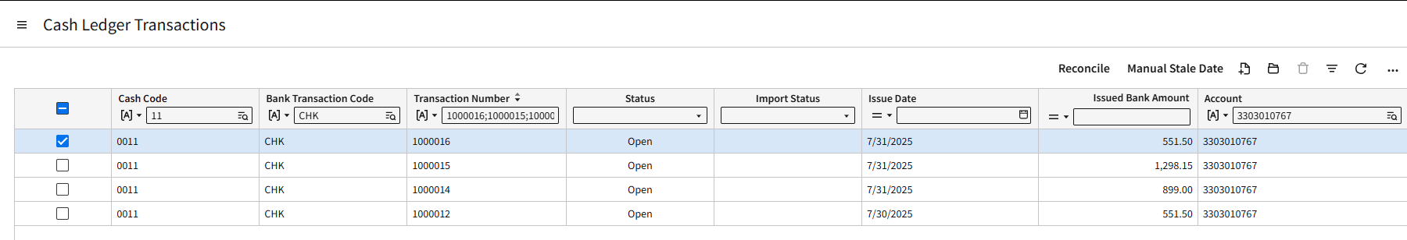
- Updated CashLedgerTransaction records to “Reconciled”
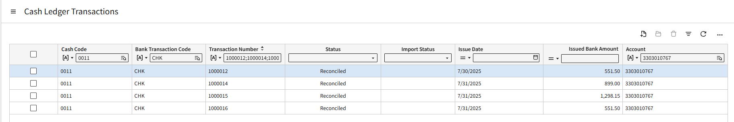

UPDATE HANDLING IN FSM AND USER ERROR RESOLUTION
Scenario | Expected Result
Introduce a full error run group deliberately and trigger error detection within FSM. | FSM should detect all records in error. All failed records in the run group remain the CashLedgerBankUpdate business class.
Introduce a partial successful and failed records deliberately and trigger partial update and error detection within FSM. | FSM should update ledger transactions for those successful records and remove them from the CashLedgerBankUpdate business class.  FSM should detect those records in error which remain in the CashLedgerBankUpdate business class and show the error message per record.
Manually fix the identified errors in FSM. | Manual fixes should be applied successfully and can rerun the Update Ledger Transactions action.
Confirm that IPA notifies the distribution group. | A timely notification should be sent to the designated distribution group showing the number of successful and failed records and a link to the Cash Ledger Bank Update Maintenance.
Review the status of Cash Ledger transactions for partial successful records. | The status of the Cash Ledger transactions for those partial successful records should match the CashLedgerUpdateAction as indicated in the bank reconciliation file.

COMPLETION OF PROCESS AND NOTIFICATION OF SUCCESSFUL UPDATE
Scenario | Expected Result
Ensure that all records intended for updating are successfully processed within CashLedgerBankUpdate business class. | All records intended for updating should be processed successfully within FSM.
Trigger a successful update process. | IPA should send a notification promptly upon successful update of cash ledger transactions.
Verify that IPA sends a notification to the distribution group confirming successful update. | The notification should confirm the successful update of cash ledger transactions.
Review the status of Cash Ledger transactions | The status of the Cash Ledger transactions should match the CashLedgerUpdateAction as indicated in the bank reconciliation file.
- Input File Contents
- Previous CashLedgerTransaction records status of “Open”


- Updated CashLedgerTransaction records to “Reconciled”


- Email Notification
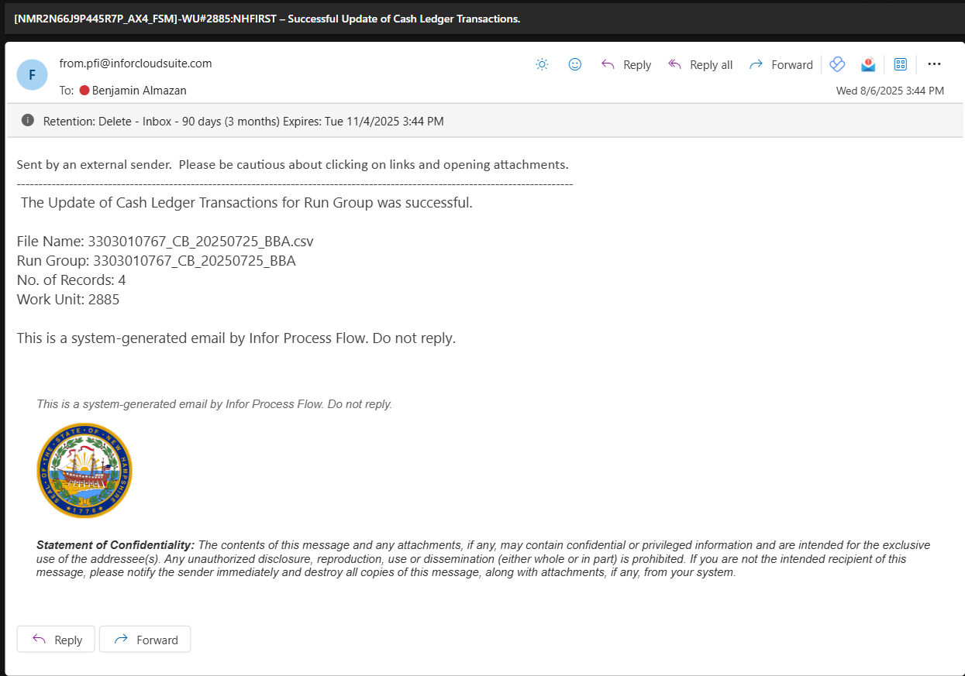

Signature
By signing this document both Infor and SoNH agree and confirm their acceptance of information contained within this specification which encompasses detailed business processes, requirements, scope and solution design.

Functional Specification

Project Sponsor | Name | Position | Date | Signature
<Client> | Treasury, DEAM
Infor | Ritchie Bachini | Consultant | July 9, 2025

Technical Specification

Project Sponsor | Name | Position | Date | Signature
<Client>
Infor

Design Sign-off

Project Sponsor | Name | Position | Date | Signature
<Client>
Infor

Testing Sign-off
Project Sponsor | Name | Position | Date | Signature
<Client>
Infor

Appendix
Bank specifications provided:

